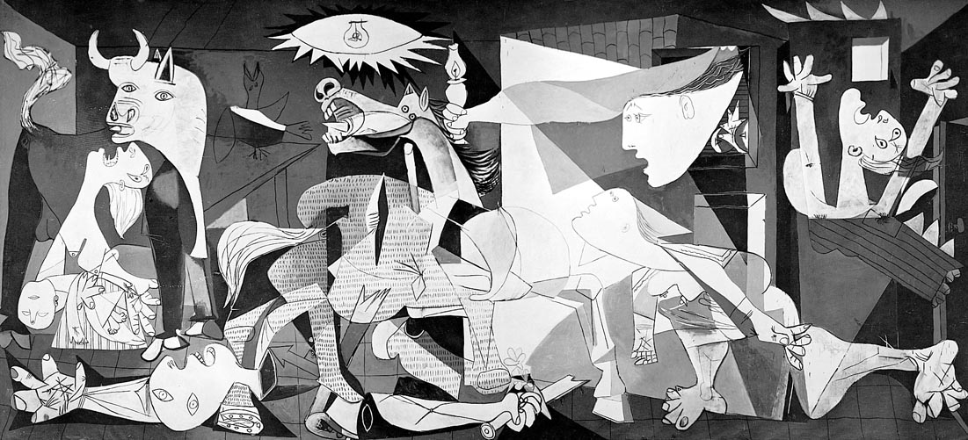

Guernica is a painting by famous Spanish artist Pablo Picasso. It was painted as a reaction to the aerial bombing of Guernica, Spain by German and Italian forces during the Spanish Civil War in 1937. The Spanish Republic, government of Spain, appointed Picasso to paint a large mural about the bombing to display at the 1937 World’s Fair in Paris.
Guernica shows the cataclysms of war as well as the anguish and destruction it inflicts upon people, especially innocent civilians. This painting has attained an enormous reputation over the years, and has become an everlasting reminder of the devastation of war, in addition to becoming an anti-war icon. After it was completed, Guernica was exhibited worldwide during a limited tour, receiving wide acclaim and becoming quite famous. The exposure assisted in bringing the Spanish Civil War to the world’s awareness.

http://totallyhistory.com/guernica/

